|  |
| --- |
| [Type the company name] |
| Assignment 02 – 2D Platformer |
| **[***Lana’s Adventure* |
| Version #2.0  All work Copyright © 2014 by KoolKatz.  All rights reserved. |
| **[Khandker Faim Hussain]** |
|  |

**Insert a Company Logo here**

|  |
| --- |
| October 27, 2015 |

**Table of Contents**

Table of Contents

**Type chapter title (level 1)1**

Type chapter title (level 2)2

Type chapter title (level 3)3

**Type chapter title (level 1)4**

Type chapter title (level 2)5

Type chapter title (level 3)6

**Version History**

* **First commit:**Added folders including: _Scenes, Materials, and Sprites as well as creating the platform material and saving the Main Scene: “**MainScene_2D-Platformer.unity”.**
* **Added the following: player's animator and script, objects including …:**  
  Failed commit using GitHub desktop.
* **Second Commit**

Added folders including: Audio, Prefabs, Animations, and _Scripts. Created Player’s animation clips and controllers (idle, walk/run, and jumping). Added sound effects and background music. Player prefab and scripts (PlayerColider and DeathTrigger).

* **Commit 3:**  
  Added: enemy sprites, enemy animation (idle and run), enemy prefab, two more scripts (EnemyController and ItemController), and an empty object for line casting used on enemy.
* **Commit 4 - (Platform spawning and backgrounds):**

Added scripts (SpawnManager and PlatformFall), used background images provided from Opengameart.org, and organized hierarchy in Unity.

* **Added:**  
  Failed commit using GitShell (Bash)
* **Commit 5 - (Score system, texts,:**

Added: scripts (ScoreManager, DamageByContact, PlayerHealth) New Audio Fixed platform spawning Inserted Canvas to recreate text Text (Slider, heart image, and damage image).

[This is the body of your video game design document. You should add and delete sections as they pertain to your game’s design.]

1. **Detailed Game Description**

*The goal of the game is for the player to survive as long as he/she can and gain the most points which is added via collecting coins on each platform. The end goal is to reach the end where the player will see their score results.*

1. **Game Play Mechanics**

*Environment and hazards: Platform falls within 5 seconds as soon as the player “hits” the platform, while avoiding ninjas and their kunai (ninja star).*

*Scoring: coins are randomly spawned on each platform in three different locations on that platform, as soon as the player “hits” one, their score increments by the value of 10.*

1. **Camera**

*2D third person, since the camera is a child of the Player object it will “scroll” in whichever direction the player moves toward.*

1. **Controls**

*Player controls: Using keyboard inputs to use horizontal movement (moving left and right) is inputted by either pushing down the “a” key or the “d” key, and pressing “w” will make the player jump.*

1. **Saving and Loading**

*There isn’t any saving that’s implemented, and since there are two scenes (Menu, and Main) it takes a couple of seconds for each scene to be “called” from one another.*

1. **Interface Sketch**

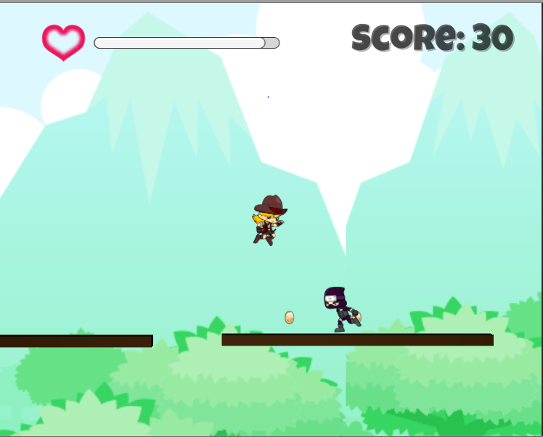

This is a screenshot during gameplay where the player has gained 30 points by collecting three coins.

1. **Character**

*The main character is a typical “cowgirl” who is on an adventure to find the lost treasure a ninja clan. Her name is Lara and has basic platforming capabilities. Her sprite is from gameart.org.*

1. **Enemies**

*The enemy ninja moves left and right on each platform and throws daggers in their facing direction at a time rate value of 3. Touching them causes no damage, since their daggers are causing damage to the player.*

1. **Scoring**Score is based on how much coins the player gets, as each coin is worth 10 points, then the score text is incremented by 10.
2. **Sound Index**

*Background music: “37 Neo Chase - Tragic Boss Battle.mp3” – (Freedom Planet)  
Coin: coin.mp3 - (Unity asset store)  
Player hurt - Player Hurt.wav (“Survival Shooter”)*

1. **Art / Multimedia Index**

*Heart image from “Survival Shooter” at Unity’s asset store.  
 Cowgirl from opengameart.org  
 Ninja from opengameart.org  
 Spinning coin from asset store*

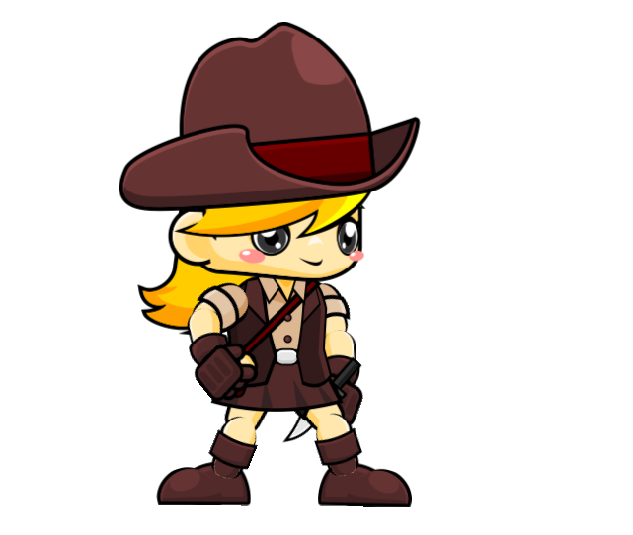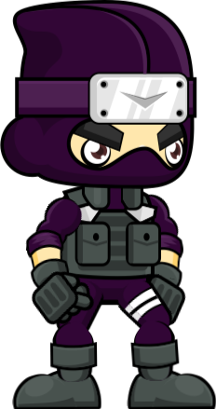

*Background image from opengameart.org*

